 | 17 Riverside Street, Ste 101, Nashua, NH 03062  9 Washington Place, Ste 101, Bedford, NH 03110  175 Rockingham Road, Londonderry, NH 03053 | P: 603.883.0091  F: 603.594.0134  nhoc.com

Arjun Dhaylan, MD

Distal Radius Fracture (Wrist Fracture): Patient Education Sheet

What Is a Distal Radius Fracture?
A distal radius fracture is a break near the end of the radius bone, just above the wrist. This is one of the most common wrist injuries and often occurs after a fall onto an outstretched hand.

Common Symptoms
- Wrist pain and swelling
- Bruising
- Limited wrist or hand motion
- Pain with gripping or lifting
- Visible deformity in some fractures

How Do These Fractures Happen?
- Falls onto the hand or wrist
- Sports injuries
- Motor vehicle accidents
- Low-energy falls in patients with weaker bone (osteoporosis)

Diagnosis
Diagnosis is made using a history, physical exam, and imaging.
- X-rays: Confirm the fracture and show alignment
- CT scan: Sometimes used for complex fractures or fractures involving the wrist joint
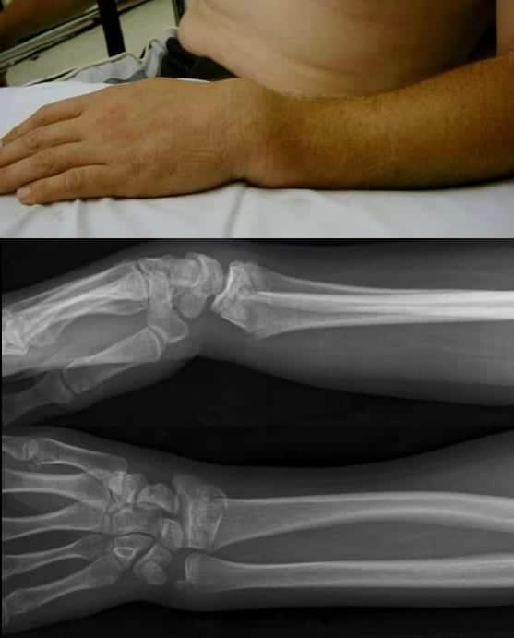

How Treatment Decisions Are Made
Treatment depends on both patient-related and fracture-related factors, including:
- Age
- Hand dominance
- Activity level and work demands
- Bone quality
- Fracture alignment and stability
- Whether the fracture involves the wrist joint

Non-Surgical Treatment
Non-surgical care may be appropriate when the fracture is well aligned or can be safely realigned.

Non-Surgical Options
- Splint or cast immobilization to allow the bone to heal
- Custom thermoplastic brace (a removable molded brace used in select fractures once swelling improves)
- Closed reduction to realign the bone before casting when needed

Expected Outcomes With Non-Surgical Care
- Most fractures heal over 6–8 weeks
- Early stiffness and weakness are common and usually improve
- Some loss of motion or strength may persist, especially if the joint is involved

Surgical Treatment
Surgery may be recommended if the fracture is unstable, poorly aligned, or involves the wrist joint.

Common Surgical Options
- Plate and screws (by far the most common method of surgical fixation, most often placed on the palm side of the wrist)
- Dorsal spanning plate, also called wrist-spanning internal fixation (a temporary plate that bridges the wrist in select fracture patterns)
- K-wires (pins) (a less common option used in select cases)

Expected Benefits of Surgery
- Improved fracture alignment
- Better stability for healing
- Faster initiation of wrist motion (range of motion) compared with non-operative care
- Improved function for fractures that cannot be reliably treated with casting alone

Recovery Expectations
- Initial immobilization followed by gradual wrist and hand motion
- Hand therapy is often recommended to restore motion and strength
- Ulnar-sided wrist pain (pain on the pinky side of the wrist) is common during recovery and usually improves with time
- Return to most daily activities over months
- Full recovery can take 12 months or longer
- Some stiffness, weakness, or aching with heavy use may persist

Key Takeaway
- Many distal radius fractures heal well with proper treatment
- Some fractures require surgery to restore alignment and function
- Recovery takes time, and gradual improvement is expected

