Volar Plate Injury

Patient Education Handout

What Is the Volar Plate?
The volar plate is a strong ligament on the palm side of the finger joint. Its main role is to prevent hyperextension (bending too far backward) and help keep the joint stable.
The volar plate is most commonly injured at the proximal interphalangeal (PIP) joint, which is the middle joint of the finger.

What Is a Volar Plate Injury?
A volar plate injury occurs when the finger is forcefully bent backward, stretching or tearing the ligament.
In some cases, the ligament pulls off a small piece of bone from the base of the middle phalanx. This is called a volar plate avulsion injury.
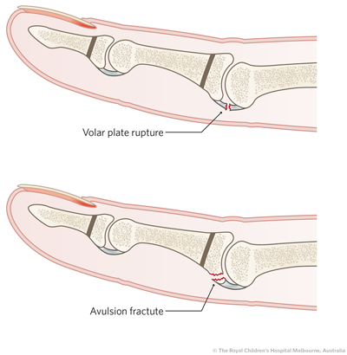

How Does This Injury Happen?
Common causes include:
- Jamming the finger during sports (ball impact)
- Falls onto an outstretched hand
- Sudden hyperextension injuries
- Contact sports or accidents

Common Symptoms
- Pain and swelling at the PIP joint
- Stiffness, especially when trying to straighten the finger
- Tenderness on the palm side of the joint
- Bruising around the joint
- Difficulty bending or fully straightening the finger
- More severe pain initially with avulsion injuries

How Is a Volar Plate Injury Diagnosed?
- Physical exam to assess swelling, tenderness, and joint stability
- X-rays to check for a volar plate avulsion fracture and joint alignment
- Advanced imaging is rarely needed

Non-Surgical Treatment Options
- Education and Symptom Awareness
  - Volar plate injuries often heal well with proper protection.
  - Early stiffness is common and usually improves with motion.
- Activity Modification
  - Avoid activities that force the finger backward or increase pain.
  - Limit gripping, contact sports, and heavy hand use during healing.
- Bracing or Splinting
  - A dorsal blocking splint or buddy taping is commonly used.
  - The finger is held slightly bent to protect the healing volar plate.
  - Splinting typically lasts 1–3 weeks, followed by gradual motion.
- Medications (Oral or Topical)
  - Anti-inflammatory medications or topical treatments may help reduce pain and swelling when appropriate.
- Hand Therapy or Exercises
  - Early guided motion is essential to prevent long-term stiffness.
  - A hand therapist may assist with safe exercises and swelling control.

When Is Surgery Considered?
Surgery is uncommon but may be recommended if:
- There is a large volar plate avulsion fracture
- The PIP joint is unstable or repeatedly dislocates
- Proper alignment cannot be maintained with splinting
Surgical treatment focuses on restoring joint stability and alignment.

Recovery Outlook
- Most volar plate injuries heal with non-surgical treatment
- Swelling and stiffness may last several weeks to months
- Early protected motion improves long-term flexibility
- Full recovery depends on injury severity and therapy participation

Warning Signs
Seek further evaluation if you have:
- Increasing pain or swelling
- A feeling the joint is unstable
- Inability to bend or straighten the finger over time
- Worsening deformity

Key Takeaways
- The volar plate prevents hyperextension of the PIP joint
- Injury commonly occurs from a jammed or bent-back finger
- Volar plate avulsion injuries involve a small bone fragment
- Most injuries heal well with splinting and early motion
- Surgery is reserved for unstable or severe cases

