Ulnar-Sided Wrist Pain

Patient Education Handout

What Is Ulnar-Sided Wrist Pain?
Ulnar-sided wrist pain refers to pain on the small-finger side of the wrist. This area contains several important structures that help with gripping, twisting, and wrist stability, which can make the exact cause of pain harder to identify.
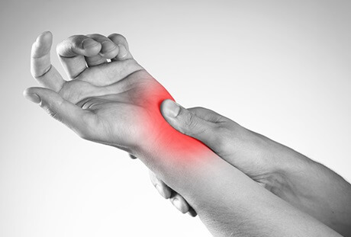

Common Causes
Ulnar-sided wrist pain may come from one or more of the following:
- TFCC injury
The triangular fibrocartilage complex (TFCC) stabilizes the wrist and absorbs shock. Injury may cause pain, clicking, or weakness.
- Ligament sprain or tear
Damage to wrist ligaments can lead to pain, swelling, or a feeling of instability.
- Tendon irritation (ECU tendon)
The extensor carpi ulnaris (ECU) tendon may become inflamed or unstable, especially with repetitive wrist motion.
- Arthritis
Wear-and-tear or inflammatory arthritis can affect the small joints on the ulnar side of the wrist.
- Bone alignment differences
Some people naturally have a slightly longer ulna bone, which can increase pressure on the TFCC.

Common Symptoms
- Pain on the small-finger side of the wrist
- Pain with gripping, twisting, or rotation
- Clicking, popping, or catching sensations
- Swelling or tenderness
- Stiffness or reduced wrist motion
- Pain when pushing up from a chair or doing push-ups
- Occasional weakness or feeling of instability

How Is the Cause Diagnosed?
- Physical exam to assess tenderness, motion, and stability
- X-rays to evaluate bone alignment and arthritis
- MRI may be used if symptoms persist or a ligament, tendon, or TFCC injury is suspected

Non-Surgical Treatment Options
- Education and Symptom Awareness
  - Many causes of ulnar-sided wrist pain improve with time and protection.
  - Pain with twisting or weight-bearing often means the wrist is irritated.
- Activity Modification
  - Avoid forceful gripping, twisting (opening jars), push-ups, and heavy lifting.
  - Use two hands when possible and keep the wrist in a neutral (straight) position.
- Bracing or Splinting
  - A wrist brace or ulnar-support brace (ex Wrist Widget) can reduce painful motion and protect healing structures.
  - Braces are often worn during activities or symptom flare-ups.
- Medications (Oral or Topical)
  - Anti-inflammatory medications or topical gels may help reduce pain and swelling when appropriate.
- Hand Therapy or Exercises
  - A hand therapist can guide gentle motion and strengthening exercises once pain improves.
  - Therapy focuses on wrist stability and balanced forearm muscle strength.
- Steroid Injection
  - In selected cases, a corticosteroid injection may reduce inflammation and pain.
  - Relief is often temporary, lasting weeks to months, and depends on the underlying cause.

When Is Surgery Considered?
Surgery is not commonly needed, but may be recommended if:
- Pain does not improve with non-surgical treatment
- There is persistent wrist instability
- Imaging shows a significant ligament, tendon, or TFCC injury
The specific procedure depends on the exact diagnosis.

Recovery Outlook
- Many patients improve with non-surgical care
- Recovery time depends on the cause and severity of symptoms
- Early protection and activity modification improve outcomes
- Some conditions may take several weeks to months to fully resolve

Warning Signs
Seek further evaluation if you have:
- Worsening pain or swelling
- Persistent clicking or catching
- A feeling that the wrist may give way
- Difficulty returning to normal activities

Key Takeaways
- Ulnar-sided wrist pain has many possible causes
- Accurate diagnosis helps guide effective treatment
- Most patients improve without surgery
- Bracing, activity changes, therapy, and injections are often helpful

