Trigger Finger (Stenosing Tenosynovitis)

Patient Education Handout

What Is Trigger Finger?
Trigger finger is a condition where a finger or thumb catches, locks, clicks, or feels stiff when bending or straightening. It occurs when the flexor tendon cannot glide smoothly through a tight tunnel called the A1 pulley at the base of the finger.

Why Does Trigger Finger Happen?
Trigger finger develops when the tendon or pulley becomes thickened and inflamed, narrowing the space for tendon movement. Common risk factors include:
- Repetitive gripping or forceful hand use
- Diabetes
- Rheumatoid arthritis or inflammatory conditions
- Prior hand strain or injury
In some patients, no clear cause is identified.
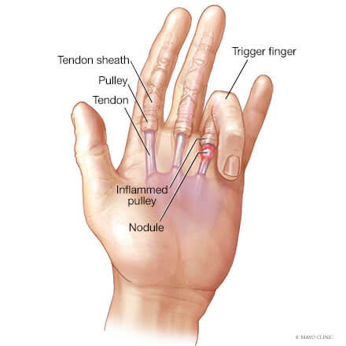

Common Symptoms
- Clicking, popping, or locking with finger motion
- Finger getting stuck in a bent position, especially in the morning
- Pain or tenderness at the base of the finger or thumb
- Stiffness, especially at the PIP joint
- Difficulty fully straightening the finger
- Symptoms often improve as the hand “warms up” but worsen again with use

How Is Trigger Finger Diagnosed?
- Diagnosis is usually made by physical exam alone
- Imaging is rarely needed

Non‑Surgical Treatment Options
- Education and Symptom Awareness
  - Early symptoms often include morning stiffness and pain at the finger base.
  - Increasing stiffness at the PIP joint may signal progression of the condition.
- Activity Modification
  - Reduce repetitive gripping, forceful squeezing, or prolonged tool use.
  - Use padded handles, larger grips, and frequent rest breaks.
- Bracing or Splinting
  - Night splints or finger splints keep the finger straight and reduce tendon irritation.
  - Splinting is most helpful in mild or early cases.
- Medications (Oral or Topical)
  - Anti‑inflammatory medications or topical gels may help pain but do not fix the mechanical blockage.
- Hand Therapy or Exercises
  - Gentle stretching may help finger and PIP joint stiffness.
  - Therapy alone is usually not enough for moderate or severe triggering.
- Steroid Injection
  - A corticosteroid injection into the tendon sheath reduces swelling and improves tendon motion. Can be an effective non-surgical treatment option.
- Steroid injections are less effective when:
  - Symptoms have been present for a long time
  - There is significant stiffness or a fixed PIP joint contracture
  - The finger frequently locks and must be manually straightened
  - The patient has diabetes (relief is still possible but recurrence is more common)
  - Multiple fingers are involved

Surgical Treatment Options
Surgery is considered when symptoms persist, return, or significantly limit hand function.

Minimally Invasive Ultrasound‑Guided Trigger Finger Release
- Performed through a very small skin opening
- Ultrasound guidance allows precise release of the tight pulley while protecting nearby nerves and blood vessels
- Typically done with local anesthesia in the office
- No stitches are usually required
- Finger motion often improves immediately
- Steroid injection can be given at the time of the procedure to decrease inflammation and pain
- Faster return to daily activities with minimal scarring

Open Trigger Finger Release
- A small incision is made in the palm to release the A1 pulley
- Long‑standing and highly reliable procedure
- Stitches are placed
Both procedures aim to restore smooth tendon gliding and eliminate locking and stiffness.

Recovery Outlook
- Many patients improve with non‑surgical treatment, especially when treated early
- Steroid injections are effective for many patients, but results depend on timing and severity
- Surgical release—open or ultrasound‑guided—has excellent long‑term results
- Most patients return to normal hand use within days to weeks

Key Takeaways
- Trigger finger causes locking, pain, and stiffness, often at the PIP joint
- Early treatment improves success of non‑surgical care
- Steroid injections work best early and are less effective with long‑standing stiffness or diabetes
- Ultrasound‑guided release is a minimally invasive surgical option with rapid recovery
- Surgical outcomes are highly reliable when needed

