 | 17 Riverside Street, Ste 101, Nashua, NH 03062  9 Washington Place, Ste 101, Bedford, NH 03110  175 Rockingham Road, Londonderry, NH 03053 | P: 603.883.0091  F: 603.594.0134  nhoc.com

Arjun Dhaylan, MD

Thumb CMC (Basal Joint) Arthritis: Patient Education Sheet

What Is Thumb CMC Arthritis?
Thumb CMC arthritis is wear-and-tear arthritis of the joint at the base of the thumb, where the thumb meets the wrist. This joint is critical for pinching and gripping. As cartilage wears down, the joint becomes painful and less stable.
It is common in:
- Women over age 40–50
- Patients with prior thumb injury
- People who do frequent pinching or gripping

Common Symptoms
- Pain at the base of the thumb
- Weakness with pinching or gripping (jars, keys, buttons)
- Swelling or tenderness at the thumb base
- Stiffness or reduced motion
- Pain that worsens with use and improves with rest

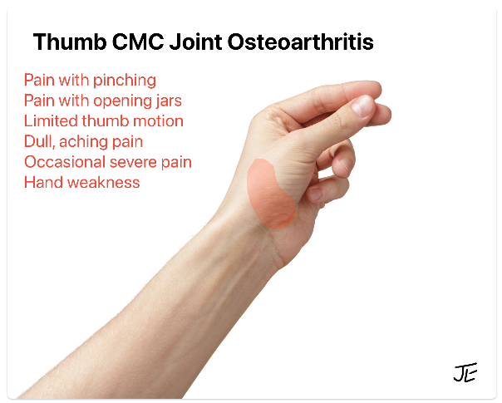

Non-Surgical Treatment Options
Listed from least invasive to more invasive.
- Activity modification
(avoiding forceful pinch, using larger handles, pacing activities)
- Bracing or splinting
(Comfort Cool®, Push MetaGrip®, or custom thermoplastic brace)
- Hand therapy / occupational therapy
(joint protection strategies, strengthening, adaptive techniques)
- Medications
  - Oral NSAIDs (ibuprofen, naproxen, celecoxib)
  - Topical NSAIDs (diclofenac gel)
  - Oral steroid taper (Medrol Dose Pack® for short-term flare control)
- Heat or ice
(heat for stiffness, ice for flares)
- Corticosteroid injection (anti-inflammatory injection into the joint)
  - Early / mild arthritis: ~70–80% short-term pain relief
  - Advanced arthritis: ~40–60% short-term pain relief
  - Duration: weeks to months
  - Repeat injections are typically spaced at least 3 months apart

Surgical Treatment Options
Surgery may be considered when pain continues despite non-surgical treatment and daily activities are limited.
- Thumb arthroscopic debridement with synovectomy
Minimally invasive procedure that cleans out inflamed tissue and loose cartilage in early arthritis
- Thumb denervation procedure
Selectively cuts pain-sensing nerves around the joint to reduce pain while preserving motion
- Basal joint arthroplasty with suture suspension
Removes the arthritic bone and uses a strong suture support to stabilize the thumb and relieve pain
The best option depends on arthritis severity, age, activity level, and goals.

What You Can Expect Long-Term
- Thumb CMC arthritis is not reversible, but symptoms are often very manageable
- Many patients do well long-term with bracing, therapy, and occasional injections
- Surgery is effective for reliable pain relief and improved function when conservative care no longer helps

Practical Tips
- Use larger grips on pens, utensils, and tools
- Use jar openers, key turners, and adaptive devices
- Avoid sustained pinch; use the whole hand when possible
- Wear your brace during painful or high-demand activities
- Take frequent breaks and alternate tasks
- Keep the thumb gently moving to avoid stiffness
- Treat flares early with rest, heat/ice, or medication

