Tennis Elbow (Lateral Epicondylitis)
Patient Education Handout

What is tennis elbow?
Tennis elbow is pain on the outside of the elbow caused by irritation and wear of the tendon that helps extend (lift up) your wrist and fingers. You do not need to play tennis to get it.

Why does it happen?
It is usually from repeated gripping or wrist motion causing microscopic damage and degeneration, such as:
- Racquet sports (tennis, pickleball)
- Tools and manual work
- Repetitive lifting
- Yard work
- Prolonged computer or mouse use

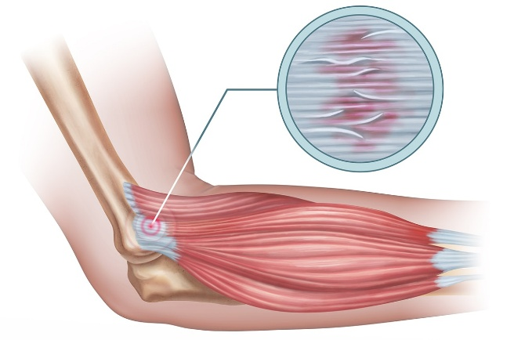

Common symptoms
- Pain or tenderness on the outside of the elbow
- Pain with gripping, lifting, or shaking hands
- Weak grip strength
- Symptoms often build up slowly

How is it diagnosed?
Most cases are diagnosed with a history and exam. X-rays, ultrasound, or MRI are only needed in select cases.

Non-Surgical Treatment Options
Listed from least to most invasive
- Activity changes and rest: Reduce painful gripping/lifting and avoid repeated wrist extension.
- Ice or heat: Ice after activity for pain; heat for stiffness.
- Anti-inflammatory medicines (NSAIDs): May help pain in the short term (if safe for you).
- Brace: A counterforce strap (forearm band) or wrist splint can reduce tendon strain.
- Occupational/physical therapy: A structured program (especially strengthening) is commonly effective over time.
- Steroid (cortisone) injection: Often improves pain short term, but high-quality studies show symptoms often recur after the initial improvement and long-term outcomes can be worse compared with therapy alone. Repeated injections are generally discouraged.
- PRP (platelet-rich plasma) injection: Uses your own blood components; results are mixed and improvement is usually gradual.
Most patients improve without surgery, but recovery often takes months, not days.

When is surgery considered?
Surgery is uncommon. It may be considered when:
- Symptoms last 6–12 months despite appropriate care
- Pain continues to limit daily activities or work

What is the outlook?
Most people improve with time and a consistent plan. Returning to activity gradually helps prevent flare-ups.

When should you call?
- Worsening pain despite treatment
- New numbness, tingling, or weakness
- Pain that significantly limits work or daily activities

