Tendonitis of the Hand, Wrist, and Forearm
Patient Education Handout

What Is Tendonitis?
Tendonitis means inflammation or irritation of a tendon. Tendons are strong cords that connect muscle to bone and allow movement of the fingers, wrist, and forearm.
When a tendon becomes irritated, it can become painful, swollen, and stiff, especially with use.
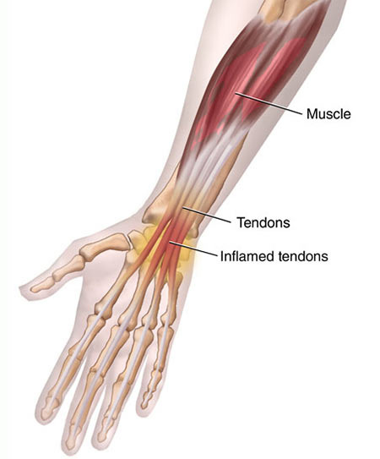

Common Symptoms
• Pain or soreness with movement
• Tenderness along the tendon
• Swelling or mild puffiness
• Stiffness, especially after rest
• Pain that worsens with gripping, lifting, or repetitive motion
• Sometimes a mild clicking or creaking sensation

Common Causes
Tendonitis is usually caused by overuse or strain, but may also result from:
• Repetitive hand or wrist motions
• Forceful gripping or lifting
• Sudden increase in activity
• Poor ergonomics or technique
• Minor injury or strain
• Inflammatory conditions (less common)
It can affect the fingers, wrist, or forearm and may involve one or multiple tendons.

How Is It Diagnosed?
Diagnosis is typically based on the following:
• Medical history and physical examination
• Evaluation of pain with motion or resistance
• X-rays to rule out bone or joint problems
• Ultrasound or MRI only if symptoms persist or diagnosis is unclear

Non-Surgical Treatment Options
(Listed from least invasive to more invasive)
1) Activity Modification
Reduce or avoid movements that irritate the tendon, such as repetitive gripping or lifting. This often helps calm inflammation and prevent flare-ups.
2) Rest and Splinting
Temporary use of a brace or splint to limit motion and allow healing. This may reduce pain and strain on the tendon.
3) Ice or Heat Therapy
Ice is helpful for pain and swelling. Heat may help stiffness. These options provide short-term symptom relief.
4) Anti-Inflammatory Medications
Medications such as ibuprofen or naproxen, if safe for you. These often help reduce pain and inflammation.
5) Hand Therapy
Guided stretching, strengthening, and activity education. This may improve motion, strength, and long-term recovery.
6) Steroid (Cortisone) Injection
Injection placed around the tendon to reduce inflammation. Relief often lasts weeks to months, though results vary.

When Is Surgery Considered?
Surgery is rarely needed for tendonitis. It may be considered if:
• Symptoms last several months despite treatment
• Pain significantly limits daily activities
• There is tendon damage or scarring
Surgery focuses on relieving pressure and removing inflamed tissue.

What Is the Outlook?
• Most patients improve with non-surgical treatment
• Recovery often takes weeks to months, depending on severity
• Gradual return to activity helps prevent recurrence
• Addressing activity habits and ergonomics improves long-term results

When to Call Your Provider
Contact your provider if you notice:
• Worsening pain or swelling
• Increasing weakness or loss of motion
• Numbness or tingling
• Symptoms that do not improve with treatment

