Triangular Fibrocartilage Complex (TFCC) Tear

Patient Education Handout

What Is the TFCC?
The triangular fibrocartilage complex (TFCC) is a group of ligaments and cartilage on the small‑finger (ulnar) side of the wrist. It works as a shock absorber and helps stabilize the wrist, especially during gripping, twisting, and rotation.

What Is a TFCC Tear?
A TFCC tear occurs when this structure is damaged. Common causes include:
- Injury, such as a fall on an outstretched hand or sudden twisting
- Repetitive use, including sports or manual work
- Wear and tear over time, especially with arthritis or certain wrist shapes
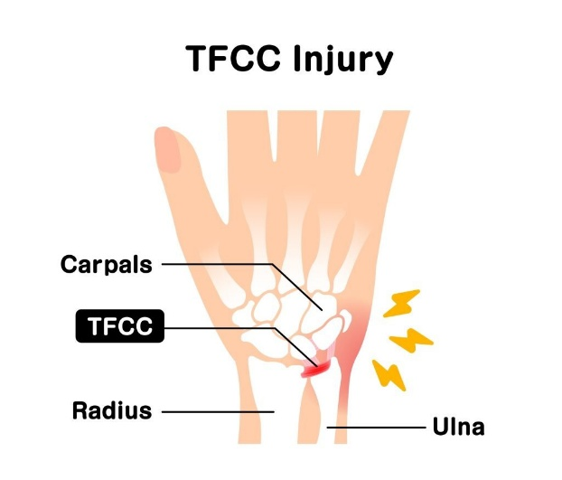

Common Symptoms
- Pain on the small‑finger side of the wrist
- Pain with gripping, twisting, or rotating the wrist
- Clicking, catching, or popping sensations
- Weakness or a feeling of wrist instability
- Pain when pushing up from a chair or doing push‑ups

How Is a TFCC Tear Diagnosed?
- Physical exam focusing on pain and wrist stability
- X‑rays to check bone alignment and arthritis
- MRI to look at the TFCC and surrounding ligaments

Non‑Surgical Treatment Options
- Education and Symptom Awareness
  - Learning which movements stress the TFCC can help prevent flare‑ups.
  - Pain with twisting, gripping, or weight‑bearing through the wrist often signals irritation.
- Activity Modification
  - Limit activities that increase pain, such as forceful gripping, twisting (opening jars), push‑ups, or heavy lifting.
  - Use two hands when possible and keep the wrist in a neutral (straight) position.
- Bracing or Splinting
  - A wrist brace, above-elbow brace or ulnar‑support brace helps reduce painful motion and protect the TFCC.
  - Braces are often worn during painful activities or at night during symptom flare‑ups.
- Medications (Oral or Topical)
  - Anti‑inflammatory medications (such as NSAIDs) or topical anti‑inflammatory gels may help reduce pain and swelling when appropriate.
- Hand Therapy or Exercises
  - A certified hand therapist can guide gentle stretching and strengthening exercises once pain improves.
  - Therapy focuses on improving wrist stability and supporting forearm muscles.
- Steroid Injection
  - A corticosteroid injection into the wrist may reduce inflammation and pain.
  - Relief is usually temporary, lasting weeks to months, but may help calm symptoms.

When Is Surgery Considered?
Surgery may be recommended if:
- Symptoms do not improve with non‑surgical care
- There is ongoing pain or wrist instability
- The tear is severe or unstable
Surgical treatment depends on the type of tear and may include arthroscopic trimming or repair.

Recovery Outlook
- Many patients improve with non‑surgical treatment
- Recovery depends on tear type, activity level, and wrist anatomy
- Early protection and activity changes often lead to better results

Key Takeaways
- The TFCC stabilizes the small‑finger side of the wrist
- Tears often cause ulnar‑sided wrist pain and clicking
- Most patients improve without surgery
- Bracing, activity changes, therapy, and injections are effective for many people

