Hand Joint Synovitis
Patient Education Sheet

What Is Synovitis?
Synovitis means inflammation (swelling and irritation) of the synovium, the thin lining inside a joint. The synovium helps joints move smoothly by producing fluid for lubrication. When it becomes inflamed, the joint may become painful, stiff, and swollen.
In the hand, synovitis can affect the finger joints or wrist and may involve one joint or several joints.
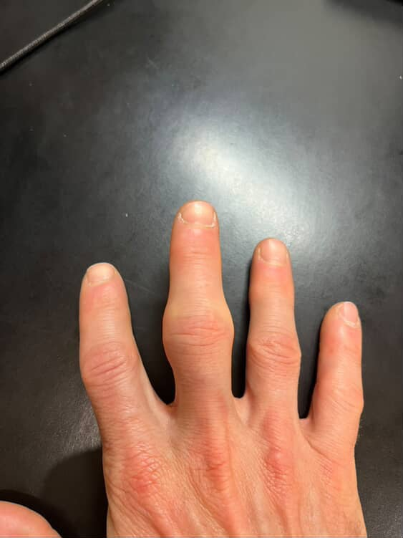

Common Symptoms
- Joint swelling or puffiness
- Pain or aching, often worse with use
- Stiffness, especially in the morning
- Warmth around the joint
- Decreased range of motion
- Sometimes a clicking or catching sensation

Common Causes
Synovitis is not a single disease. It is a joint reaction that may be caused by:
- Overuse or repetitive motion
- Arthritis (such as osteoarthritis or inflammatory arthritis)
- Injury or sprain
- Inflammatory conditions (for example, rheumatoid arthritis)
- Unknown causes (idiopathic)

How Is It Diagnosed?
Diagnosis is usually based on:
- A medical history and physical examination
- X-rays to evaluate joint alignment and arthritis
- Ultrasound or MRI to assess synovial swelling (if needed)
- Blood tests only when an inflammatory condition is suspected

Non-Surgical Treatment Options
1. Activity Modification
Avoiding or reducing activities that irritate the joint, such as repetitive gripping or pinching. Often helps decrease inflammation and prevent flare-ups.
2. Splinting or Bracing
Temporary use of a finger or hand splint to rest the joint. May reduce pain and swelling while the joint heals.
3. Anti-Inflammatory Medications
Medications such as ibuprofen or naproxen, if safe for you. Often helps reduce pain and swelling.
4. Ice or Heat Therapy
Ice for swelling and soreness; heat for stiffness. Provides short-term symptom relief.
5. Hand Therapy
Guided exercises and techniques to control swelling and improve motion. May improve flexibility, strength, and function.
6. Steroid (Cortisone) Injection
Medication injected directly into the joint to reduce inflammation. Often provides relief for weeks to months, however results may vary.

When Is Surgery Considered?
Surgery is not commonly needed for simple synovitis. It may be considered if:
- Symptoms persist for several months despite non-surgical treatment
- Inflammation is severe or recurrent
- Synovitis is affecting joint motion or nearby tendons

Surgery focuses on removing inflamed synovial tissue to reduce pain and protect joint function.

What Is the Outlook?
- Many patients improve with non-surgical treatment
- Symptoms may come and go, especially with activity
- Treating the underlying cause, when identified, improves long-term results

When to Call Your Provider
Contact your provider if you notice:
- Increasing pain or swelling
- Worsening stiffness or loss of motion
- Redness, warmth, or fever
- Symptoms that do not improve with treatment

