 | 17 Riverside Street, Ste 101, Nashua, NH 03062  9 Washington Place, Ste 101, Bedford, NH 03110  175 Rockingham Road, Londonderry, NH 03053 | P: 603.883.0091  F: 603.594.0134  nhoc.com

Arjun Dhaylan, MD

Proximal Interphalangeal (PIP) Joint Arthritis: Patient Education Sheet

What Is PIP Joint Arthritis?
The PIP joint is the middle joint of the finger. Arthritis occurs when the smooth cartilage covering the ends of the bones wears down. This causes the bones to rub together, leading to pain, stiffness, swelling, and loss of motion.
PIP joint arthritis is commonly due to osteoarthritis (wear-and-tear), but it can also occur with inflammatory arthritis (such as rheumatoid arthritis) or after a prior finger injury.

Common Symptoms
- Pain in the middle finger joint
- Stiffness, especially in the morning or after rest
- Swelling or warmth around the joint
- Difficulty bending or straightening the finger
- Weak grip or trouble making a fist
- Joint enlargement or finger deformity over time

Causes and Risk Factors
- Normal aging and cartilage wear
- Prior finger injury or dislocation
- Inflammatory arthritis conditions
- Family history of arthritis
- Repetitive hand use or heavy gripping

How Is It Diagnosed?
- Review of symptoms and physical exam
- X-rays showing cartilage loss, joint narrowing, or bone spurs
- Advanced imaging is rarely needed.
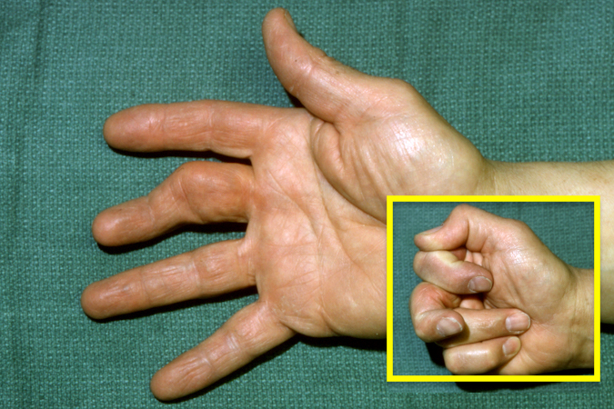

Non-Surgical Treatment Options
(Listed from least invasive to more invasive)
- Activity modification (avoiding painful gripping or forceful use) – often helps reduce flare-ups.
- Heat or ice (heat for stiffness, ice for swelling) – commonly improves comfort.
- Oral pain medication (acetaminophen or anti-inflammatory medicine, if safe for you) – may reduce pain and inflammation.
- Topical anti-inflammatory gel (applied to the joint) – may help pain with fewer whole-body side effects.
- Splinting or buddy taping (supporting the joint during activities or rest) – may improve comfort and stability.
- Hand therapy (guided exercises and joint protection techniques) – may improve motion and function.
- Steroid injection (medication placed into the joint) – may reduce pain and swelling for weeks to months; results vary and repeat injections are limited.
Many patients manage symptoms successfully with these treatments.

Surgical Treatment
Surgery may be considered when pain, stiffness, or deformity continue despite non-surgical care and interfere with daily activities.

Common Surgical Options
- PIP Joint Fusion (Arthrodesis) – permanently stiffens the joint to eliminate pain; provides a strong, stable finger but no motion at that joint.
- PIP Joint Replacement (Arthroplasty) – replaces the joint surfaces to reduce pain and preserve some motion; best for select patients, with variable durability.

Outlook
- PIP joint arthritis is common and can affect hand function
- Symptoms may fluctuate over time
- Many patients improve with non-surgical treatment
- Surgical treatment, when needed, can significantly reduce pain and improve hand use

