Paronychia

Patient Education Handout

What Is Paronychia?
Paronychia is an infection or inflammation of the skin around the fingernail or toenail. It most often affects the area where the nail meets the skin (the nail fold).
Paronychia may be:
- Acute – sudden onset, usually caused by bacteria
- Chronic – long-lasting irritation or inflammation, often related to moisture or repeated trauma
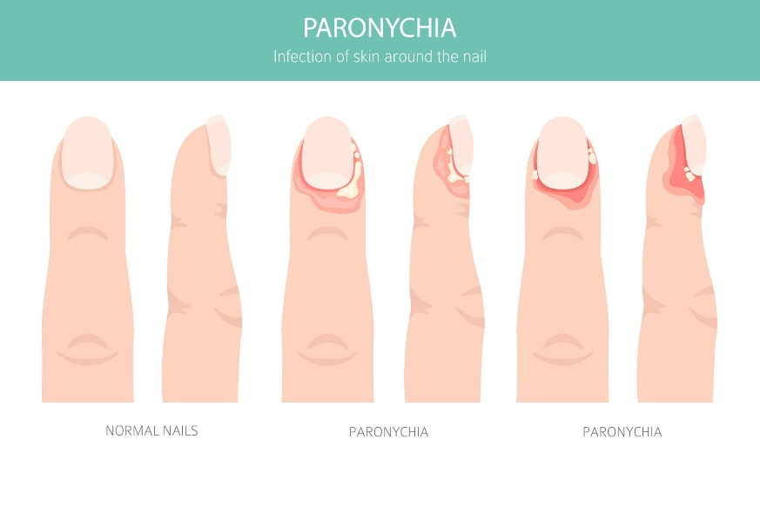

What Causes Paronychia?
Common causes include:
- Hangnails or nail biting
- Cuticle trimming or manicures
- Ingrown nails
- Frequent exposure to water, soaps, or chemicals
- Small cuts or cracks in the skin around the nail

Common Symptoms
- Redness and swelling around the nail
- Pain or tenderness at the nail edge
- Warmth of the surrounding skin
- Pus or drainage (more common in acute infections)
- Shiny or tight skin around the nail
- In chronic cases: less pain but persistent redness, swelling, and nail changes

How Is Paronychia Diagnosed?
- Diagnosis is usually made by physical exam
- Imaging is rarely needed
- Cultures are not routinely required unless infection is severe or recurrent

Non-Surgical Treatment Options
- Education and Symptom Awareness
  - Early treatment helps prevent worsening infection.
  - Increasing pain, swelling, or pus suggests active infection.
- Activity Modification
  - Avoid nail biting, picking, or trimming the cuticle.
  - Limit prolonged water exposure and wear gloves for cleaning or dishwashing.
- Warm Soaks
  - Soak the affected finger or toe in warm water for 10–15 minutes, 2–4 times daily.
  - Warm soaks help reduce pain and encourage drainage.
- Medications (Topical or Oral)
  - Topical antibiotic ointments may help mild infections.
  - Oral antibiotics may be prescribed if redness spreads, pain worsens, or infection is more severe.
  - Chronic paronychia may be treated with topical anti-inflammatory or antifungal medications, depending on the cause.

When Is a Procedure Needed?
A simple drainage procedure may be needed if:
- There is a collection of pus
- Pain is severe or worsening
- Symptoms do not improve with soaks and medication
This is usually a quick office procedure performed with local numbing.

Recovery Outlook
- Most acute cases improve within days to one week with proper care
- Chronic paronychia may take several weeks to resolve
- Keeping the nail area dry and protected helps prevent recurrence

Warning Signs
Seek medical care if you have:
- Rapidly worsening pain or swelling
- Spreading redness up the finger or toe
- Fever or chills
- No improvement after several days of treatment

Key Takeaways
- Paronychia is an infection around the nail
- Early treatment prevents abscess formation
- Warm soaks and protection are key first steps
- Drainage or antibiotics may be needed in more severe cases
- Avoiding cuticle trauma helps prevent recurrence

