Olecranon Bursitis (Elbow Bursitis)

What Is Olecranon Bursitis?
The olecranon bursa is a small, fluid-filled sac over the tip of the elbow. It helps the skin glide smoothly over the bone. Olecranon bursitis occurs when this sac becomes irritated and fills with extra fluid, causing swelling at the back of the elbow.
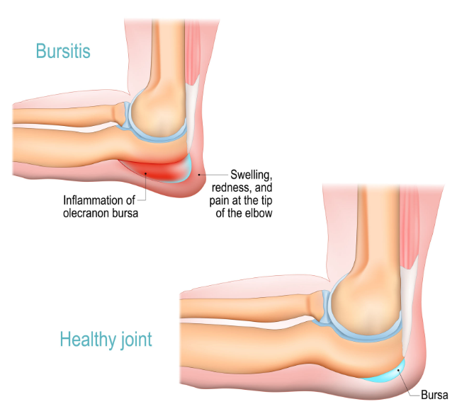

Aseptic vs. Septic Bursitis (Important Difference)

Aseptic (Non‑Infected) Bursitis
- Most common type
- Caused by repeated pressure, leaning on the elbow, minor trauma, or overuse
- Swelling is often painless or mildly sore
- Skin is usually not red or warm
- No fever or chills

Septic (Infected) Bursitis
- Caused by bacteria entering the bursa, often through a small skin break
- Swelling is painful
- Skin may be red, warm, and tender
- Fever, chills, or feeling ill may occur
- Requires prompt medical treatment
Contact your doctor urgently if redness, warmth, fever, drainage, or worsening pain develops.

Common Symptoms
- Soft or firm swelling over the tip of the elbow
- Pressure discomfort or aching
- Skin irritation from resting on hard surfaces
- Limited elbow motion due to swelling

Non‑Surgical Treatment Options

Activity Modification
- Avoid leaning on the elbow or resting it on hard surfaces
- Often allows swelling to improve over time

Ice and Anti‑Inflammatory Medication
- Ice packs for 15–20 minutes at a time
- Anti‑inflammatory medications if safe for you
- Often helps reduce pain and swelling

Padding the Elbow (Very Important)
Protecting the elbow from pressure is a key part of treatment:
- Foam or gel elbow pads
- Cushioned elbow sleeves
- Custom foam padding secured with a light wrap
- Helps prevent continued irritation and recurrence

Compression
Compression can help limit fluid buildup:
- Elastic compression wrap
- Neoprene elbow sleeve
- Padded compression elbow brace
- Should feel snug but not tight or painful

Aspiration (Draining the Fluid)
Aspiration involves placing a needle into the bursa to remove fluid.
- In aseptic (non‑infected) olecranon bursitis, aspiration often provides only short‑term reduction in swelling
- Fluid commonly re‑accumulates, particularly if pressure on the elbow continues
- When used routinely for aseptic bursitis, aspiration may increase the risk of developing septic bursitis
- For these reasons, aspiration is generally avoided in non‑infected olecranon bursitis
Aspiration may be considered selectively when:
- Infection is suspected and fluid testing is needed
- Swelling is very large and threatens the overlying skin
- The diagnosis is uncertain and infection must be ruled out

Septic Bursitis: When Antibiotics Alone May Be Appropriate
Based on published guidelines and reviews, septic olecranon bursitis may sometimes be treated initially with antibiotics alone when:
- The patient is clinically stable
- There is no significant deep infection
- There is no abscess or open draining wound
- There are no signs of severe systemic illness
- The immune system is normal

Treatment usually includes oral antibiotics, protection of the elbow, and close follow‑up to ensure improvement.
Drainage or surgery is more likely to be needed if symptoms worsen, fail to improve, recur, or if the patient has risk factors such as immune suppression.

When Is Surgery Considered?
Surgery is uncommon and is typically reserved for:
- Persistent or severe septic bursitis
- Infection that does not improve with appropriate antibiotics
- Recurrent infections or a chronically infected, thickened bursa

Outlook
- Aseptic olecranon bursitis often improves with time, padding, compression, and avoiding pressure
- Septic bursitis usually improves with prompt antibiotics and careful monitoring
- Preventing repeated pressure on the elbow is the most important factor in recovery

Key Takeaways
- Most elbow bursitis is not infected
- Padding and pressure avoidance are essential
- Aspiration is generally avoided for non‑infected bursitis
- Some stable infections can be treated with antibiotics alone
- Seek care promptly for redness, warmth, fever, or worsening pain

