 | 17 Riverside Street, Ste 101, Nashua, NH 03062  9 Washington Place, Ste 101, Bedford, NH 03110  175 Rockingham Road, Londonderry, NH 03053 | P: 603.883.0091  F: 603.594.0134  nhoc.com

Arjun Dhaylan, MD

Mucous Cyst of the Finger: Patient Education Sheet

What Is a Mucous Cyst?
A mucous cyst (also called a digital mucous cyst) is a small, fluid-filled bump that forms on the back or side of a finger near the last finger joint (the joint closest to the nail). It is benign (not cancer).
These cysts are commonly related to arthritis in the nearby joint. Extra joint fluid can push through a weak area in the joint lining and collect under the skin.
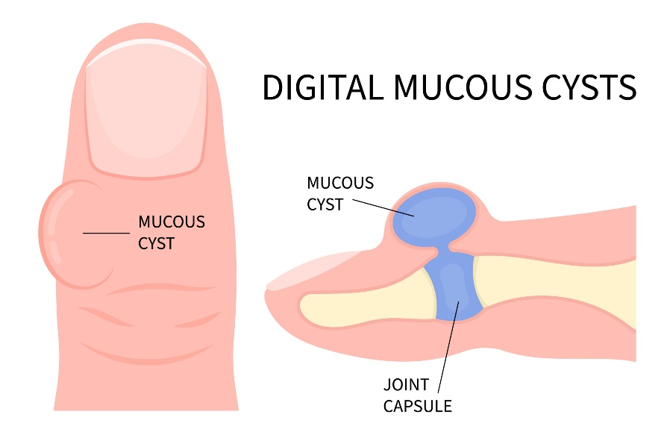

Where Do They Appear?
- Near the end joint of the finger
- Often close to the nail
- May press on the nail root and cause a groove or ridge in the nail

Common Symptoms
- Visible bump near the nail or joint
- Clear or jelly-like fluid inside
- Usually painless, but may feel tender or tight
- Nail changes (grooving or deformity)

Important Safety Warning
Do NOT pop, squeeze, or drain the cyst yourself.
Mucous cysts often connect directly to the joint. If the skin opens: - Bacteria can enter the joint - This can cause a serious joint infection
Call your doctor right away if the cyst opens, leaks fluid, becomes red, warm, painful, swollen, or if you develop fever.

Non-Surgical Treatment Options
(Listed from least invasive to most invasive)
- Observation – Reasonable if the cyst is painless and not causing problems
- Protective padding or splinting – May reduce irritation from pressure
- Aspiration (needle drainage) – Fluid is removed in the office; the cyst often returns
- Steroid injection – May temporarily reduce swelling; results vary and recurrence is common

Surgical & Procedure-Based Options

Office-Based or Outpatient Surgery
- Performed with local anesthesia
- The cyst and its connection to the joint are removed
- A small bone spur may also be treated if present

Minimally Invasive (Percutaneous) Techniques
- Uses a small needle or tiny incision
- Performed in the office
- Faster recovery

What to Expect After Treatment
- Small bandage or dressing
- Mild soreness for a few days
- Gentle finger motion is usually encouraged
- Gradual return to normal activities as healing allows

Possible Risks (Uncommon)
- Cyst recurrence
- Infection
- Temporary stiffness or soreness
- Persistent nail deformity

When to Call Your Doctor
- Increasing redness, swelling, or pain
- Drainage from the cyst or incision
- Fever or chills
- New numbness or difficulty moving the finger

Bottom Line
A mucous cyst is a common, non-cancerous finger condition often related to arthritis. While it may look harmless, opening or popping it can lead to infection. Safe treatment options range from observation to minimally invasive or surgical removal, with surgery offering the best chance of permanent resolution.

