 | 17 Riverside Street, Ste 101, Nashua, NH 03062  9 Washington Place, Ste 101, Bedford, NH 03110  175 Rockingham Road, Londonderry, NH 03053 | P: 603.883.0091  F: 603.594.0134  nhoc.com

Arjun Dhaylan, MD

Management of Fingertip Injuries: Patient Education Sheet
Fingertip injuries can heal beautifully and naturally by keeping the area clean and covered for about 2-3 months. Just follow these simple steps:
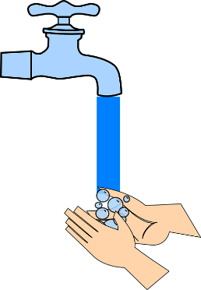
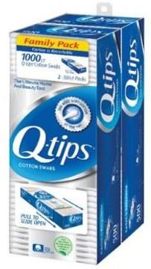
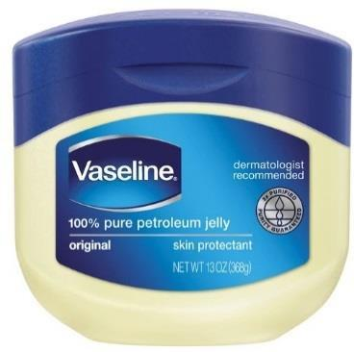
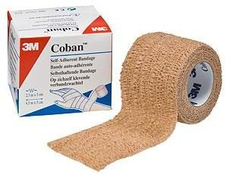
- Wash the area daily with normal tap water. This is most easily done with a daily shower on a naked finger.
- Clean off excess smelly goop with a Q-tip.
- Apply Vaseline to the area like spreading peanut butter on toast
- Wrap with Coban (vet wrap)
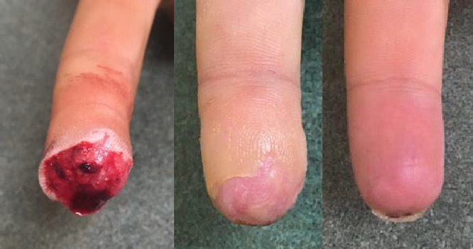
- Use your finger normally to avoid it getting stiff

Injury 5 weeks 11 weeks

