 | 17 Riverside Street, Ste 101, Nashua, NH 03062  9 Washington Place, Ste 101, Bedford, NH 03110  175 Rockingham Road, Londonderry, NH 03053 | P: 603.883.0091  F: 603.594.0134  nhoc.com

Arjun Dhaylan, MD

Mallet Finger: Patient Education Sheet

What Is Mallet Finger?
A mallet finger is an injury to the tendon that straightens the tip of the finger. It happens when the fingertip is suddenly bent forcefully, causing the tendon to tear or pull off a small piece of bone.
As a result, the fingertip droops and cannot be actively straightened.
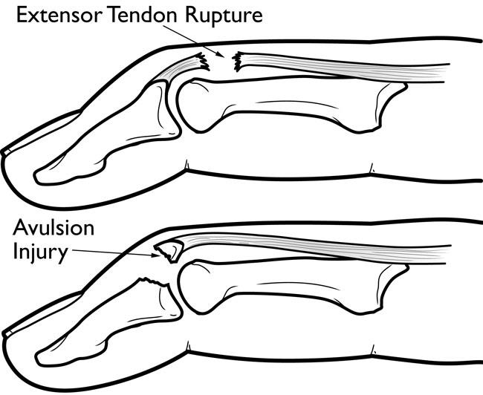

Why This Injury Is Often Underestimated
Mallet finger can look minor at first, but proper treatment is critical. Even small gaps in treatment can prevent healing.
Recovery often takes 8–12 weeks or longer, and strict splint use is required for the best outcome.

Common Symptoms
- Drooping of the fingertip
- Inability to actively straighten the fingertip
- Pain and swelling at the end joint (DIP joint)
- Bruising or tenderness
Some patients have little pain despite significant injury.

Goals of Treatment
- Allow the tendon or bone to heal properly
- Restore fingertip extension
- Prevent long-term deformity or stiffness

Non-Surgical Treatment Options
(Listed from least to most invasive)
- Continuous splinting
A splint holds the fingertip fully straight while the tendon heals. The splint must be worn at all times, including during sleep and bathing.
- Skin care and splint checks
Regular skin inspection and hygiene help prevent sores while wearing the splint.
- Hand therapy guidance
Education on splint use and safe motion of nearby joints helps avoid stiffness.
Most effective initial approach: Full-time splinting of the fingertip in extension for 6–8 weeks, followed by gradual weaning and nighttime splinting, is highly effective for most mallet finger injuries when done correctly.

When Is Surgery Considered?
Surgery is needed in limited situations, such as: - A large fracture involving the joint surface
- Joint misalignment or subluxation
- Inability to maintain finger extension in a splint
- Open injuries or skin breakdown

Imaging and the Role of X-rays
- X-rays are commonly obtained to look for an associated fracture or joint alignment problems.
- X-rays help determine whether the injury is a tendon-only mallet or a bony mallet fracture, which can affect treatment decisions.

Healing and Recovery Timeline
- Continuous splinting: 6–8 weeks
- Nighttime splinting: additional 2–4 weeks
- Mild drooping or stiffness may persist despite good healing
Even with proper treatment, a small residual bend at the fingertip is common and usually does not affect function.

Possible Long-Term Effects
- Mild extensor lag (slight droop)
- Stiffness at the fingertip
- Skin irritation from splinting
Most patients regain good function with proper splint use.

When to Call Your Provider
Contact your doctor if you notice: - Skin sores or breakdown under the splint
- Increasing pain or swelling
- Inability to keep the fingertip fully straight
- Numbness or color changes

Key Takeaway
Mallet finger requires strict, continuous splinting and patience. When treated correctly, most injuries heal well without surgery.
Mallet Finger Splint Weaning Protocol
Purpose
This protocol outlines safe, gradual weaning from a mallet finger splint after successful full-time splinting. Following these steps closely helps protect the healing tendon and reduce the risk of recurrent drooping.

Splint Weaning Schedule
Week 1
- You may remove the splint for up to 1 hour at a time during the day.
- Only remove the splint if no extension lag (droop) develops.
- Wear the splint full-time at night.
- Begin gentle composite flexion (bending) exercises of the finger.
Week 2
- You may be out of the splint for the majority of the day, as long as no droop develops.
- Wear the splint full-time at night.
- Continue gentle composite flexion exercises.
Weeks 3–4
- No splint is needed during the day.
- Wear the splint full-time at night.
- Continue gentle composite flexion exercises.
After Week 4
- You may stop wearing the splint completely.
- Gradually return to all activities as tolerated.

Important Warning
- If you notice a new or worsening extension lag (droop) at any point:
  - Resume full-time splint wear immediately.
  - Contact the office for further instructions.

Expectations After Recovery
- It is normal to have a 10–20 degree extension lag (droop) even with excellent splint compliance. This is considered a successful outcome.
- It is common to have minor skin irritation on the back of the finger and a small bump near the injury site. These changes may or may not fully resolve over time.

Orthosis Options
- Alumafoam splints
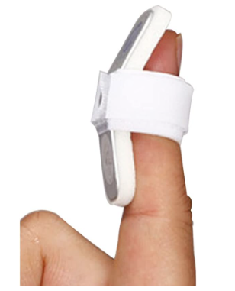

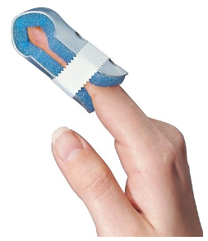

- Oval-8 splint
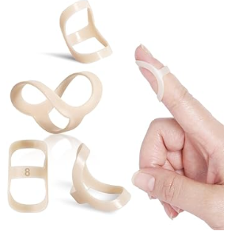

- Stax splint
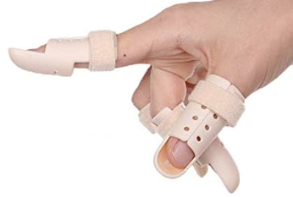

4. Custom occupational therapy-made splint
