 | 17 Riverside Street, Ste 101, Nashua, NH 03062  9 Washington Place, Ste 101, Bedford, NH 03110  175 Rockingham Road, Londonderry, NH 03053 | P: 603.883.0091  F: 603.594.0134  nhoc.com

Arjun Dhaylan, MD

Ligament Sprain: Patient Education Sheet
(Including PIP Joint Sprains)
Patient Education Sheet

What Is a Finger Ligament Sprain?
A finger ligament sprain occurs when one or more ligaments that stabilize a finger joint are stretched or torn. Ligaments are strong bands of tissue that connect bone to bone and keep joints stable.
The most commonly injured joint is the PIP joint (the middle joint of the finger). PIP ligament sprains are very common and often occur after a jammed finger, fall, or ball-related injury.

Why This Injury Is Often Underestimated
Although a finger sprain may seem minor, ligament injuries in the finger—especially at the PIP joint—heal slowly. Swelling, stiffness, and soreness can last much longer than patients expect.
It is common for recovery to take several months, even when the ligament heals properly.
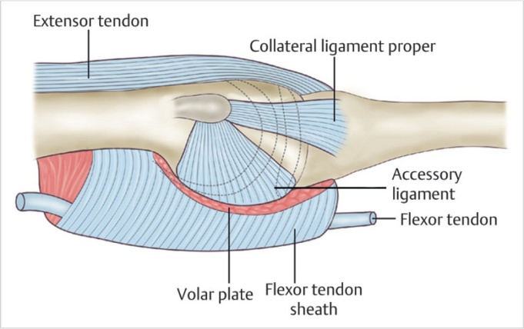

Common Symptoms
- Pain at the injured joint
- Swelling that may last weeks to months
- Stiffness, especially with bending or straightening
- Tenderness along the sides of the joint
- Feeling of weakness or instability (less common)

Goals of Treatment
- Protect the injured ligament while it heals
- Restore motion without causing instability
- Reduce swelling and pain
- Prevent long-term stiffness

Non-Surgical Treatment Options
(Listed from least to most invasive)
- Activity modification
Avoiding activities that stress the finger allows the ligament to heal.
- Ice and anti-inflammatory medications
Ice and medications such as NSAIDs may help reduce pain and swelling, especially early on.
- Buddy taping
Taping the injured finger to a neighboring finger provides support while allowing safe motion. This is the most common treatment for PIP ligament sprains.
- Protective splinting
A short-term splint may be used for more painful or unstable injuries, followed by early motion.
- Hand therapy
Guided exercises help restore motion, reduce stiffness, and protect healing ligaments. This is especially important for PIP joint injuries.
Most effective initial approach: Buddy taping combined with early, controlled motion and hand therapy is most effective for the majority of finger and PIP ligament sprains.

When Is Surgery Considered?
Surgery is rarely needed. It may be considered if:
- The joint is unstable or dislocated
- There is a large ligament tear with persistent instability
- There is an associated fracture affecting joint alignment

Imaging and the Role of MRI
X-rays are often obtained to check for fractures or joint alignment problems.
MRI is not routinely needed for finger ligament sprains. It may be considered only in limited situations, such as: - Ongoing pain, swelling, or instability after 6–8 weeks of appropriate treatment
- Concern for a complete ligament rupture or complex injury
- Unclear diagnosis after exam and X-rays
- Surgical planning when symptoms do not improve
In most cases, MRI findings do not change treatment.

Healing and Recovery Timeline
- Swelling often lasts weeks to months
- Stiffness is common and improves slowly
- Pain typically improves before swelling resolves
- Full recovery may take 3–6 months, and sometimes longer for PIP joint injuries
Mild swelling or stiffness may persist even after good functional recovery.

Possible Long-Term Effects
- Residual swelling or joint thickening
- Mild stiffness, especially at the PIP joint
- Occasional soreness with heavy use
Most patients regain good function with proper treatment and patience.

When to Call Your Provider
Contact your doctor if you notice:
- Worsening pain or swelling
- Increasing stiffness despite exercises
- A feeling that the joint is unstable or giving way
- Inability to bend or straighten the finger

Key Takeaway
Finger ligament sprains—especially PIP joint sprains—often take much longer to heal than expected. Early protection, controlled motion, and patience are critical for the best outcome.

