 | 17 Riverside Street, Ste 101, Nashua, NH 03062  9 Washington Place, Ste 101, Bedford, NH 03110  175 Rockingham Road, Londonderry, NH 03053 | P: 603.883.0091  F: 603.594.0134  nhoc.com

Arjun Dhaylan, MD

Golfer’s Elbow (Medical Epicondylitis): Patient Education Sheet

What Is Golfer’s Elbow?
Golfer’s elbow, also called medial epicondylitis, is a condition that causes pain on the inside of the elbow. It happens when the tendons that attach the forearm muscles to the elbow become irritated or damaged from overuse or repetitive stress.
These tendons help with gripping, wrist bending, and forearm motion.
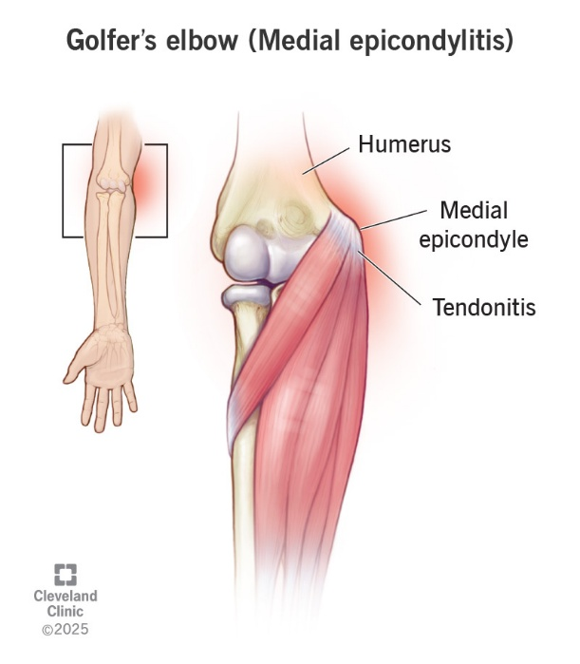

Common Symptoms
- Pain or tenderness on the inside of the elbow
- Pain that may spread down the forearm
- Weak grip strength
- Stiffness or soreness with wrist bending or gripping activities
Symptoms often worsen with activities such as lifting, gripping, or sports.

What Causes It?
Golfer’s elbow is most often caused by repeated stress on the forearm muscles and tendons. This can occur from:
- Sports that involve gripping or swinging
- Repetitive work activities
- Heavy lifting or forceful wrist motion
It does not require playing golf to develop this condition.

Goals of Treatment
- Reduce pain and inflammation
- Allow the tendon to heal
- Restore strength and function
- Prevent recurrence

Non-Surgical Treatment Options
(Listed from least to most invasive)
- Activity modification
Reducing or avoiding activities that worsen pain allows the tendon to rest and heal.
- Ice and anti-inflammatory medications
Ice and medications such as NSAIDs may help decrease pain and swelling.
- Brace or strap
A forearm strap or elbow brace reduces stress on the injured tendon during activity.
- Hand therapy or physical therapy
Stretching and strengthening exercises improve flexibility and tendon health. This often helps reduce pain and improve function.
- Steroid injection
A cortisone injection may temporarily reduce pain and inflammation. Relief typically lasts weeks to months, and results vary.
- Platelet-rich plasma (PRP) injection
PRP uses a concentrated sample of your own blood that is injected into the injured tendon to promote healing. Research shows mixed results—some studies suggest longer-term pain relief compared to steroid injections, while others show no clear benefit. PRP is often not covered by insurance and is commonly an out-of-pocket expense.
Most effective initial approach: A combination of activity modification, a forearm brace or strap, and a structured therapy program focused on stretching and gradual strengthening is most commonly effective for early management.

When Is Surgery Considered?
Surgery is rarely needed. It may be considered if:
- Symptoms last 6–12 months despite non-surgical treatment
- Pain significantly limits daily activities or work

Surgical Treatment Option
- Tendon debridement and repair
Damaged tendon tissue is removed, and healthy tendon may be repaired or reattached. This is usually done as an outpatient procedure.

Healing and Recovery
- Improvement often occurs gradually over several weeks to months
- Most patients return to normal activities without surgery
- Recovery after surgery may take several months

Possible Long-Term Effects
- Recurring pain if activities are resumed too quickly
- Persistent soreness (uncommon with proper treatment)
- Stiffness (rare)

When to Call Your Provider
Contact your doctor if you notice:
- Worsening pain despite treatment
- Increasing weakness or numbness
- Difficulty using the hand or arm

