 | 17 Riverside Street, Ste 101, Nashua, NH 03062  9 Washington Place, Ste 101, Bedford, NH 03110  175 Rockingham Road, Londonderry, NH 03053 | P: 603.883.0091  F: 603.594.0134  nhoc.com

Arjun Dhaylan, MD

Ganglion Cyst Patient Education Sheet

What Is a Ganglion Cyst?
A ganglion cyst is a non-cancerous, fluid-filled lump that forms near a joint or tendon. It most commonly appears on the wrist or hand, but it can also occur on the fingers or foot. The cyst is filled with a thick, clear fluid similar to joint fluid.
Ganglion cysts may change in size and can sometimes come and go on their own.
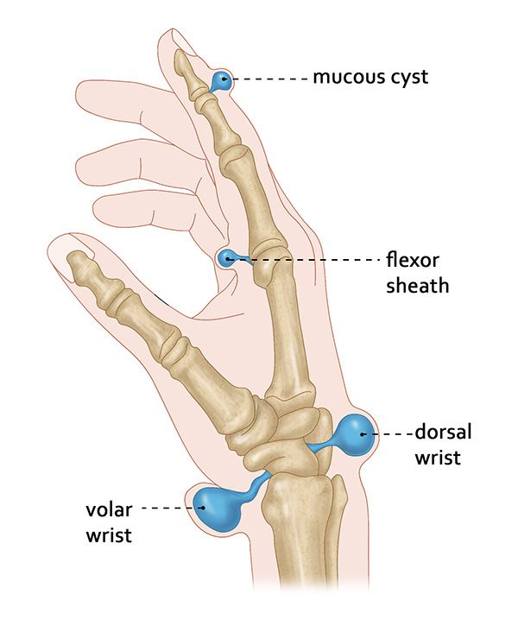

Common Symptoms
- A visible or palpable lump near the wrist or hand
- Pain or aching, especially with movement or pressure
- Weakness or decreased grip strength
- Tingling or numbness if the cyst presses on a nerve
Some ganglion cysts cause no pain at all.

Why Do Ganglion Cysts Form?
The exact cause is not always known. They are thought to form when joint or tendon fluid leaks out and becomes trapped in a small sac. They are more common in younger adults but can occur at any age.

Goals of Treatment
- Reduce pain or discomfort
- Improve hand or wrist function
- Address cosmetic concerns if bothersome
- Prevent recurrence when possible

Non-Surgical Treatment Options
(Listed from least to most invasive)
- Observation
Many ganglion cysts are harmless and may shrink or disappear on their own over time. Observation is appropriate if symptoms are mild.
- Activity modification
Avoiding activities that worsen pain may help reduce symptoms.
- Brace or splint
Temporary immobilization can decrease movement-related pain and may reduce cyst size.
- Aspiration (needle drainage)
The fluid is removed with a needle in the office. This may relieve symptoms, but the cyst often comes back over time.

When Is Surgery Considered?
Surgery may be recommended if: - Pain persists despite non-surgical treatment
- The cyst limits daily activities or work
- There is pressure on nearby nerves
- The cyst repeatedly comes back after aspiration

Surgical Treatment Option
- Ganglion cyst excision
The cyst and its connection to the joint or tendon are removed through a small incision. This is usually done as an outpatient procedure.

Healing and Recovery
- Mild soreness and swelling are common after treatment
- Return to light activities usually occurs within days to weeks
- Full recovery depends on the cyst location and treatment type

Possible Long-Term Effects
- Recurrence of the cyst
- Stiffness or soreness (usually temporary)
- Scar sensitivity after surgery

When to Call Your Provider
Contact your doctor if you notice:
- Increasing pain, redness, or swelling
- Signs of infection such as drainage or fever
- Worsening numbness or weakness

