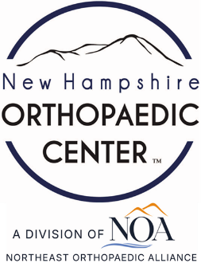 | 17 Riverside Street, Ste 101, Nashua, NH 03062  9 Washington Place, Ste 101, Bedford, NH 03110  175 Rockingham Road, Londonderry, NH 03053 | P: 603.883.0091  F: 603.594.0134  nhoc.com

Arjun Dhaylan, MD

Fingertip Orthosis Treatment Options: Patient Education Sheet
- Alumafoam splints
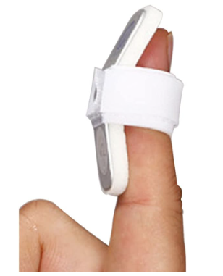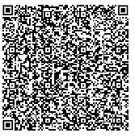

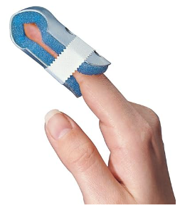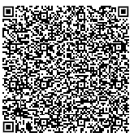

- Oval-8 splint
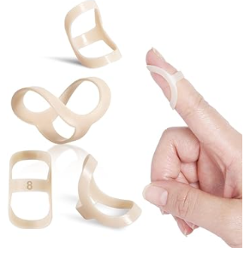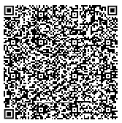
- Stax splint
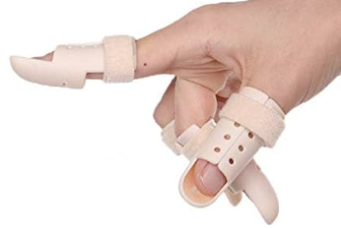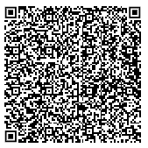
- Custom occupational therapy-made splint
