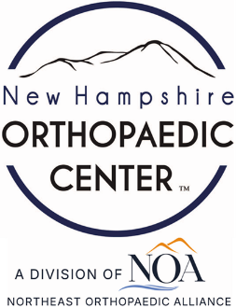 | 17 Riverside Street, Ste 101, Nashua, NH 03062  9 Washington Place, Ste 101, Bedford, NH 03110  175 Rockingham Road, Londonderry, NH 03053 | P: 603.883.0091  F: 603.594.0134  nhoc.com

Arjun Dhaylan, MD

Fingertip Amputation Patient Education Sheet

What Is a Fingertip Amputation?
A fingertip amputation means that part of the tip of the finger has been cut or crushed off. This may include loss of skin, nail, bone, and soft tissue. Fingertip injuries are common and often happen at work or at home.
The fingertip is important for:
- Feeling and sensation
- Fine hand movements
- Protecting the end of the finger

How Serious Is It?
The severity depends on:
- How much tissue is missing
- Wound contamination level
- Whether bone is exposed
- The condition of the remaining skin and nail
- Which finger is injured
Many fingertip amputations heal well with proper care, even without surgery.

Common Symptoms
- Pain and bleeding
- Sensitivity to touch or cold
- Loss of nail or fingertip shape
- Numbness or tingling (may improve over time)

Goals of Treatment
- Control pain and prevent infection
- Promote healing
- Restore function and sensation as much as possible
- Create a comfortable, durable fingertip

Non-Surgical Treatment Options
(Listed from least to most invasive)
- Wound care and dressings
Regular cleaning and protective bandages allow the fingertip to heal on its own over time. This is often effective for smaller injuries, even when a small amount of bone is exposed.
- Splinting or protective caps
A splint or fingertip cap protects the injured area during daily activities and helps reduce pain while healing.
- Hand therapy
Guided exercises and desensitization techniques may improve motion and help decrease fingertip sensitivity.
Many fingertip amputations heal by secondary intention, meaning the body gradually fills in the wound naturally.
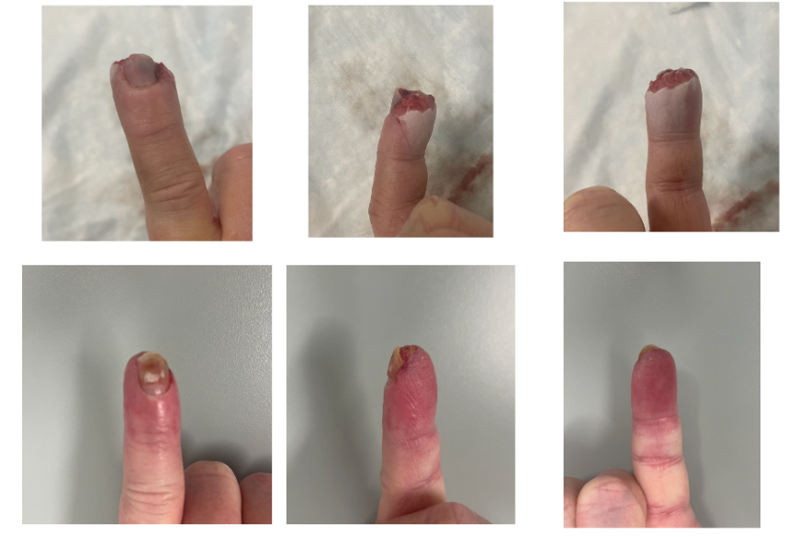

When Is Surgery Considered?
Surgery may be recommended if:
- A large amount of tissue is missing
- The wound bed is contaminated
- Bone is exposed and cannot be shortened safely
- The wound cannot heal on its own
- Pain, function, or appearance would likely be poor without surgery

Surgical Treatment Options
- Bone shortening and closure
If bone is exposed, a small amount may be trimmed so the skin can safely close over the fingertip.
- Skin graft
Skin taken from another area of the body is used to cover the wound when there is not enough local skin.
- Local flap reconstruction
Nearby finger skin is moved to cover the fingertip and provide durable padding.
The choice of surgery depends on the injury pattern and patient needs.

Healing and Recovery
- Healing usually takes several weeks
- Sensitivity and cold intolerance are common early and often improve
- Nail growth may be altered or incomplete
- Most patients regain good function for daily activities

Possible Long-Term Effects
- Mild numbness or sensitivity
- Changes in nail appearance
- Cold sensitivity
- Stiffness (uncommon with early motion)

When to Call Your Provider
Contact your doctor if you notice:
- Increasing pain, redness, or swelling
- Drainage or foul odor
- Fever or chills
- Worsening numbness or color changes

