 | 17 Riverside Street, Ste 101, Nashua, NH 03062  9 Washington Place, Ste 101, Bedford, NH 03110  175 Rockingham Road, Londonderry, NH 03053 | P: 603.883.0091  F: 603.594.0134  nhoc.com

Arjun Dhaylan, MD

Dupuytren’s Disease (Dupuytren’s Contracture): Patient Education Sheet

What Is Dupuytren’s Disease?
Dupuytren’s disease is a condition where the tissue under the skin of the palm (palmar fascia) becomes thick and tight over time. This can form nodules and cords that gradually pull one or more fingers into a bent position.
It is not a tendon problem and is not caused by overuse or injury.
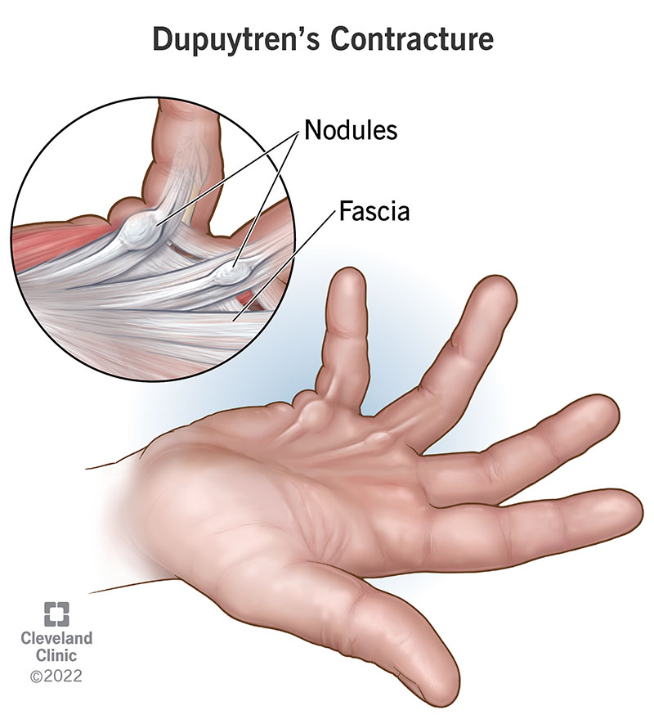

Common Symptoms
- Firm lumps (nodules) in the palm
- Tight cords under the skin
- Fingers that slowly bend toward the palm and cannot fully straighten
- Most often affects the ring and small fingers
- Usually painless, but hand function may become limited

Who Gets Dupuytren’s Disease?
- More common in men
- Often runs in families
- More common in people of Northern European ancestry
- Associated with diabetes, smoking, and alcohol use

Diagnosis
Dupuytren’s disease is diagnosed with a history and physical exam.
- Examination for nodules, cords, and finger contractures
- Tabletop test (inability to place the hand flat on a table)
- X-rays or advanced imaging are usually not needed

Important Things to Know
- Dupuytren’s disease is slowly progressive
- Not everyone with nodules will develop finger contractures
- Treatment is based on loss of hand function, not appearance
- Recurrence can occur after all treatment options

Non-Surgical Treatment Options
(Listed from least to most invasive)
- Observation (no treatment if fingers are straight and function is good)
- Stretching and hand therapy (may help comfort, but does not stop progression)
- Steroid (cortisone) injection into a painful nodule (may reduce tenderness; does not correct finger bending)

Procedural and Surgical Treatment Options
Treatment is usually considered when a finger cannot fully straighten and daily function is affected.

Needle Aponeurotomy (with Cortisone Injection)
- A needle is used to weaken and release the cord through small skin punctures
- A cortisone injection is typically given at the time of the procedure
- Performed in the office with local anesthesia
- Quick recovery
- Overall outcomes and recurrence rates are similar to Xiaflex®

Enzyme Injection (Xiaflex®)
- An enzyme injection that dissolves the cord, followed by finger manipulation
- Minimally invasive with relatively fast recovery
- Side effects are common but usually minor, including local swelling, bruising, and skin tears
- Overall outcomes and recurrence rates are similar to needle aponeurotomy

Surgical Fasciectomy
- Diseased tissue is removed through an incision
- Can be performed as a limited fasciectomy or a subtotal fasciectomy (depending on degree of contracture and patient preference)
- Longer recovery compared with less invasive options
- Lowest recurrence rate of all treatment options

Recovery Expectations
- Recovery time depends on the treatment chosen
- Temporary swelling, stiffness, and soreness are common
- Hand therapy and splinting are often recommended after procedures or surgery
- Improved finger position is common, but full straightening is not always possible

Key Takeaway
- Dupuytren’s disease is a benign but progressive hand condition
- Needle aponeurotomy (with cortisone) and Xiaflex® offer similar results with faster recovery but higher recurrence
- Surgical fasciectomy has the lowest recurrence rate but requires longer recovery
- The goal of treatment is to improve hand function, not cure the disease

