 | 17 Riverside Street, Ste 101, Nashua, NH 03062  9 Washington Place, Ste 101, Bedford, NH 03110  175 Rockingham Road, Londonderry, NH 03053 | P: 603.883.0091  F: 603.594.0134  nhoc.com

Arjun Dhaylan, MD

De Quervain’s Tendonitis: Patient Education Sheet

What Is De Quervain’s Tendonitis?
De Quervain’s tendonitis is irritation and swelling of two tendons on the thumb side of the wrist. These tendons help move the thumb away from the hand. When they become inflamed or tight, thumb and wrist movement can become painful.

Common Symptoms
- Pain on the thumb side of the wrist
- Pain with gripping, pinching, lifting, or twisting
- Swelling or tenderness near the base of the thumb
- Pain when moving the thumb or bending the wrist
- Symptoms often worsen with repetitive use or lifting
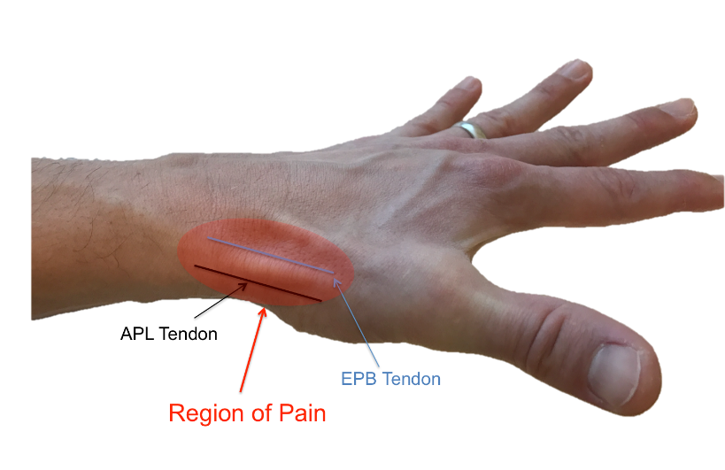

Why Does It Happen?
- Repetitive thumb or wrist motion
- Forceful gripping or lifting
- Sudden increase in hand activities
- Pregnancy or postpartum period
(Sometimes no clear cause is identified)

Diagnosis
De Quervain’s tendonitis is usually diagnosed with a history and physical exam.
- Physical exam: Tenderness over the thumb-side wrist and pain with thumb motion
- Ultrasound: May be used to show tendon swelling or thickening and can help guide injections if needed
- X-rays are usually not required unless another condition is suspected

Non-Surgical Treatment Options
(Listed from least to most invasive)
- Activity modification (avoiding painful gripping or repetitive thumb motion; often improves symptoms)
- Thumb spica splint (rests the thumb and wrist; commonly reduces pain)
- Anti-inflammatory medications (may help pain and swelling)
- Steroid injection (reduces tendon swelling; relief often lasts weeks to months and is commonly effective)
Many patients improve without surgery.

Surgical Treatment
Surgery may be recommended if symptoms continue despite non-surgical care.
- Releases the tight tendon sheath so the tendons can glide freely
- Performed as an outpatient procedure
- Usually done with local anesthesia
- Involves a small incision on the thumb side of the wrist

What to Expect After Treatment
- Pain relief often begins within days to weeks
- Temporary soreness near the injection or incision is common
- Gradual return to normal thumb and wrist use
- Most patients regain comfortable motion and function

