 | 17 Riverside Street, Ste 101, Nashua, NH 03062  9 Washington Place, Ste 101, Bedford, NH 03110  175 Rockingham Road, Londonderry, NH 03053 | P: 603.883.0091  F: 603.594.0134  nhoc.com

Arjun Dhaylan, MD

Cubital Tunnel Syndrome: Patient Education Sheet

What Is Cubital Tunnel Syndrome?
Cubital tunnel syndrome occurs when the ulnar nerve is compressed or irritated as it passes behind the inside of the elbow (the cubital tunnel). The ulnar nerve provides feeling to the ring and small fingers and controls some of the small muscles in the hand.
Pressure on this nerve can cause numbness, tingling, pain, and weakness in the hand and arm.

Common Symptoms
- Numbness or tingling in the ring and small fingers
- Symptoms worse when the elbow is bent (sleeping or phone use)
- Aching pain on the inside of the elbow
- Hand weakness or clumsiness
- Difficulty with fine motor tasks
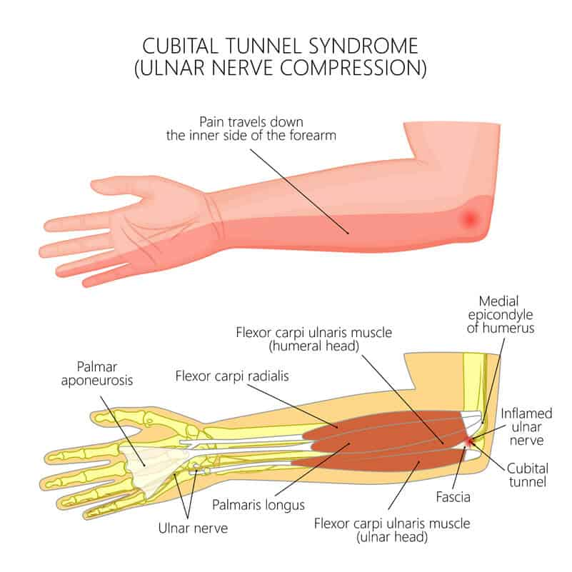
- Muscle wasting in severe or long-standing
cases

Causes
- Prolonged or repeated elbow bending
- Leaning on the elbow for long periods
- Elbow arthritis or bone spurs
- Prior elbow injury
- Tight tissues around the nerve
- Nerve instability (snapping over the elbow)

How Is It Diagnosed?
- Physical exam to assess sensation, strength, and nerve irritation
- Nerve conduction study / EMG to evaluate nerve function
- Ultrasound may be used to evaluate the ulnar nerve
- X-rays may be used to look for arthritis or bone spurs

Non-Surgical Treatment Options
(Listed from least invasive to more invasive)
- Activity modification (avoiding prolonged elbow bending or pressure) – often improves symptoms.
- Night elbow splinting or towel wrap (keeps the elbow straighter during sleep) – commonly reduces numbness.
- Elbow padding during daily activities – may reduce nerve irritation.
- Anti-inflammatory medication (if safe for you) – may help pain and swelling.
- Hand therapy (nerve-gliding exercises and education) – may help in mild to moderate cases.
Many patients improve with these treatments, especially when started early.

Surgical Treatment
Surgery may be considered when symptoms persist despite non-surgical care or if there is weakness or muscle wasting.

Common Surgical Options
- Cubital tunnel release – relieves pressure on the nerve
- Ulnar nerve transposition – moves the nerve to a safer position (used in select cases)
Surgery is typically performed as an outpatient procedure.

Outlook
- Early treatment often improves symptoms
- Long-standing nerve compression can cause permanent weakness or numbness
- Surgery, when needed, commonly improves symptoms and helps prevent further nerve damage

