 | 17 Riverside Street, Ste 101, Nashua, NH 03062  9 Washington Place, Ste 101, Bedford, NH 03110  175 Rockingham Road, Londonderry, NH 03053 | P: 603.883.0091  F: 603.594.0134  nhoc.com

Arjun Dhaylan, MD

Carpal Tunnel Syndrome (CTS): Patient Education Sheet

What Is Carpal Tunnel Syndrome?
Carpal tunnel syndrome happens when the median nerve is squeezed as it passes through a narrow space in the wrist called the carpal tunnel. This pressure can cause pain, numbness, tingling, and weakness in the hand.

Common Symptoms
- Numbness or tingling in the thumb, index, middle, and part of the ring finger
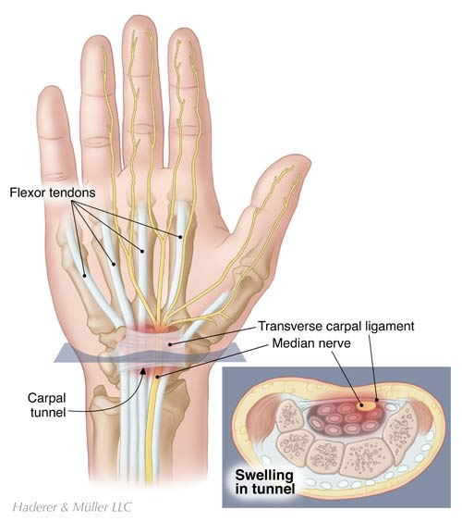
- Hand pain, often worse at night
- Weak grip or dropping objects
- Symptoms may improve when shaking the hand

Why Does CTS Happen?
- Repetitive hand use
- Wrist positioning or swelling
- Diabetes, thyroid disease, or arthritis
- Pregnancy or fluid retention
(Often, no single cause is found)

Diagnosis
Carpal tunnel syndrome is diagnosed using your symptoms, a physical exam, and sometimes tests to confirm nerve pressure and rule out other causes.
Common tools include:
- Exam tests (checking feeling, thumb strength, and wrist/hand positions that reproduce symptoms)
- Nerve test (EMG/NCS) (measures how well the median nerve conducts signals; helpful to grade severity)
- Ultrasound (can show swelling/enlargement of the median nerve at the wrist and look for contributing problems; painless and quick)

Non-Surgical Treatment Options
(Listed from least to most invasive)
- Activity changes (avoiding prolonged wrist bending; often helps mild symptoms) (avoiding prolonged wrist bending; often helps mild symptoms)
- Night wrist splint (keeps wrist straight; commonly reduces nighttime numbness)
- Anti-inflammatory medications (may help pain; limited effect on nerve pressure)
- Steroid injection (reduces swelling around the nerve; relief often lasts weeks to months)
If symptoms persist, worsen, or cause weakness, surgery may be recommended.

Surgical Treatment: Carpal Tunnel Release (CTR)
Surgery relieves pressure by cutting the transverse carpal ligament, creating more space for the nerve.

Mini-Open vs Single-Portal Endoscopic Carpal Tunnel Release
- Mini-Open CTR: Small incision in the palm; direct view of the ligament; reliable and widely used.
- Single-Portal Endoscopic CTR: One small incision using a camera-assisted system through a single portal; may allow faster early recovery and less palm soreness.
Both techniques have similar long-term success and nerve relief.

Where Is the Surgery Done?
- Office Procedure Room (Mini-Open CTR only): Performed using local anesthesia only; fastest setup and recovery.
- Surgery Center (Mini-Open or Single-Portal Endoscopic CTR): Required for endoscopic CTR; local anesthesia only is still an option, with the choice of added light sedation if desired.

What to Expect After Surgery
- Same-day procedure
- Immediate relief of nighttime numbness is common
- Palm soreness for several weeks is normal
- Gradual return to full hand use over weeks
- Strength improves over time
- Full nerve recovery is not guaranteed, though most patients continue to recover nerve function as time goes on

