Complex Regional Pain Syndrome (CRPS)

Patient Education Handout

What Is CRPS?
Complex Regional Pain Syndrome (CRPS) is a condition that causes ongoing pain, sensitivity, swelling, and stiffness in an arm, hand, leg, or foot. The pain is often out of proportion to the original injury and is related to abnormal nerve signaling and inflammation.
CRPS often develops after an injury, fracture, surgery, or prolonged immobilization, even when healing appears normal.

Types of CRPS
There are two types of CRPS. Symptoms are very similar, but the cause differs:
- CRPS Type 1
  - Occurs without a known nerve injury
  - Most common type
  - Often follows a fracture, sprain, surgery, or casting
  - Nerves are irritated or overactive but not clearly damaged
- CRPS Type 2
  - Occurs after a known nerve injury
  - Previously called causalgia
  - May follow a laceration, surgical nerve injury, or significant trauma
  - Symptoms often follow the path of the injured nerve
Both types cause real, physical symptoms and are treated in similar ways.

Why Does CRPS Happen?
The exact cause is not fully understood. CRPS is thought to involve:
- Overactive pain nerves
- Abnormal inflammation
- Changes in blood flow and temperature regulation
- Altered communication between the brain and the affected limb
CRPS is not psychological, although chronic pain can affect mood and stress levels.

Common Symptoms
Symptoms may change over time and vary between individuals. Common features include:
- Severe, burning, or aching pain
- Extreme sensitivity to touch, pressure, or temperature
- Swelling of the hand or fingers
- Color changes (red, purple, pale, or blotchy skin)
- Temperature changes (warmer or cooler than the opposite side)
- Stiffness and limited motion
- Shiny skin or changes in sweating
- Changes in nail or hair growth
- Weakness or difficulty using the hand

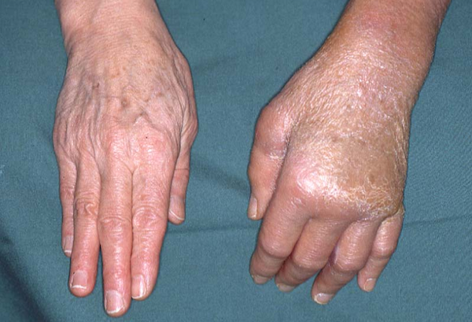

How Is CRPS Diagnosed?
- Diagnosis is based on symptoms and physical exam findings
- There is no single test that confirms CRPS
- Imaging or nerve tests may be used to rule out other conditions
- Early diagnosis improves outcomes

Non-Surgical Treatment Options
- Education and Symptom Awareness
  - Understanding CRPS reduces fear and improves recovery.
  - Pain with movement does not mean damage is occurring.
- Activity Modification
  - Avoid prolonged immobilization.
  - Gentle, regular use of the affected limb is encouraged.
- Medications (Oral or Topical)
  - Medications may help calm nerve pain or inflammation.
  - These help manage symptoms but do not cure CRPS.
- Hand Therapy or Exercises
  - Hand therapy is the cornerstone of CRPS treatment.
  - Therapy focuses on gentle motion, swelling control, functional use, and gradual strengthening.
  - Daily home exercises are essential.
- Desensitization Techniques
  - Gradual exposure to textures and temperatures retrains overactive nerves.
  - Usually guided by a hand therapist.

Other Treatments That May Be Used
- Pain management referral
- Nerve blocks or injections in selected cases
- Psychological support to help manage chronic pain stress (this does not mean symptoms are imagined)

When Is Surgery Considered?
There is no standard surgical treatment for CRPS. Surgery is usually avoided, as it can worsen symptoms unless another clear structural problem exists.

Recovery Outlook
- CRPS improves gradually, not overnight. Recovery usually occurs over months, not days or weeks.
- With early diagnosis and active treatment, many patients notice meaningful improvement within 3–6 months.
- Continued progress often occurs over 6–12 months, especially with consistent therapy.
- Some patients may have residual symptoms (mild stiffness, sensitivity, or color changes) even as function improves.
- Earlier treatment leads to better and faster recovery. Long-standing CRPS may take longer to resolve.
- Flare-ups can occur during recovery and do not mean treatment has failed.

What Patients Can Do to Help Recovery
- Stay moving
  - Gentle, regular use of the affected hand retrains the nervous system and prevents stiffness.
- Commit to therapy
  - Attend therapy visits consistently and perform home exercises daily.
- Practice desensitization
  - Use therapist-guided texture and temperature exercises to calm pain nerves.
- Avoid immobilization
  - Prolonged splinting or avoiding use can worsen stiffness and symptoms.
- Manage swelling
  - Elevation, compression, and gentle motion help control swelling.
- Manage stress and sleep
  - Stress and poor sleep increase pain sensitivity.
  - Relaxation, pacing, and good sleep habits support healing.
- Stay engaged and patient
  - Recovery is gradual; consistency matters more than speed.

Warning Signs
Seek further evaluation if you notice:
- Rapid worsening of pain or swelling
- Increasing stiffness or loss of motion
- New or worsening skin color or temperature changes
- Declining function despite therapy

Key Takeaways
- CRPS causes severe pain, sensitivity, and stiffness after injury or surgery
- Type 1 occurs without a known nerve injury; Type 2 follows a clear nerve injury
- Symptoms are real and related to nerve dysfunction
- Early movement and hand therapy are critical
- Most patients improve with a team-based, non-surgical approach

